K.R. MANGALAM UNIVERSITY
SCHOOL OF ENGINEERING AND TECHNOLOGY



LAB FILE

COURSE NAME: COMPUTER NETWORK
COURSE CODE: ENCS352
SUBMISSION IN THE NAME OF: SIDDHANT JHA
ROLL NUMBER: 2301730219
COURSE: BTECH CSE (AI and ML)
SUBMITTED TO: MS. JYOTI KAURAV

TABLE OF CONTENTS
S.No. | Experiments | Date
1 | Introduction to Computer Networks and Cisco Packet Tracer (CPT).
 | A. Studying the Cisco Packet Tracker (CPT) Interface. | 12.01.26
 | B. Implementing a Peer-to-Peer Network. | 12.01.26
2 | Visualizing the various Network Topologies:  - Mesh Topology  - Bus Topology  - Ring Topology  - Tree Topology  - Star Topology | 09.02.26  09.02.26  02.02.26  23.02.26  19.01.26
3 | Constructing and understanding the purpose of a LAN.
 | A. LAN using a Hub. | 02.03.26
 | B. LAN using a Switch. | 23.02.26
4 | Implementation of a Campus Area Network (CAN): Design and the IP assignment. | 30.03.26
5 | Implementing over the IP Layer:
 | A. Understanding the concept of Subnetting. | 06.04.26
 | B. Implementing Traceroute and the Ping Command in CPT. | 23.03.26
6 | Wireless Home Network: Setting up a Router. | 13.04.26
7 | Capstone Project. | 20.04.26

EXPERIMENT 1

INTRODUCTION TO COMPUTER NETWORKS AND THE CISCO PACKET TRACER (CPT)

- Studying the Cisco Packet Tracer (CPT) Interface.
2
3
4
1

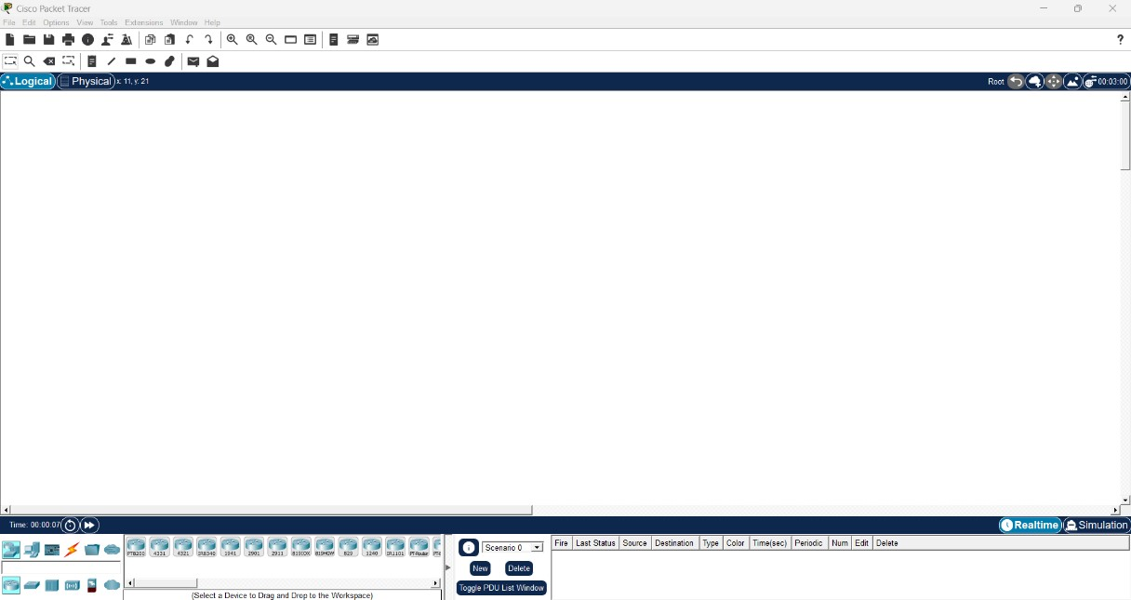
Cisco Packet Tracker: Realtime View.

5
8
6
7
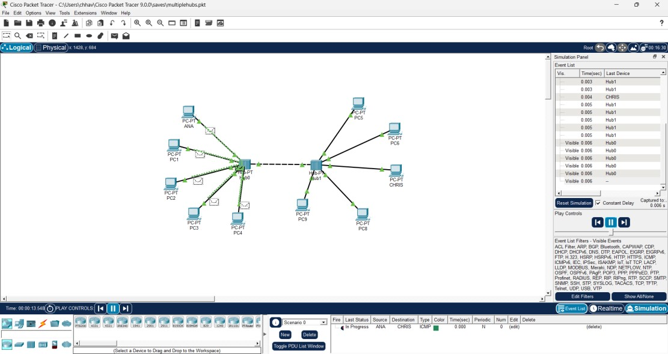
Cisco Packet Tracker: Simulation View.

Key | Features
1 | Workspace: This area is where you will create your network, watch simulations, and view many kinds of information and statistics.
2 | Menu Bar: This bar provides the File, Edit, Options, View, Tools, Extensions, Window and Help menus.
3 | Main Tool Bar: This bar provides shortcut icons to most used menu commands.
4 | Common Tools Bar: This bar provides access to these commonly used workspace tools: Select, Inspect, Delete, Resize Shape, Place Note, Drawing Palette, Add Simple PDU, and Add Complex PDU.
5 | Logical/Physical Workspace and Navigation Bar: You can toggle between the Physical Workspace and the Logical Workspace with the tabs on this bar.
6 | Device-Type Selection Box: This box contains the type of devices and connections available in Packet Tracer. The Device-Specific Selection Box will change depending on which type of device you choose.
7 | User Created Packet Window: This window manages the packets you put in the network during simulation scenarios. See the "Simulation Mode" section for more details.
8 | Realtime/Simulation Bar: You can toggle between Realtime Mode and  Simulation Mode with the tabs on this bar. This bar also provides buttons to Power Cycle Devices and Fast Forward Time as well as the Play Control buttons and the Event List toggle button in Simulation Mode

- Implementing a Peer-to-Peer Network.

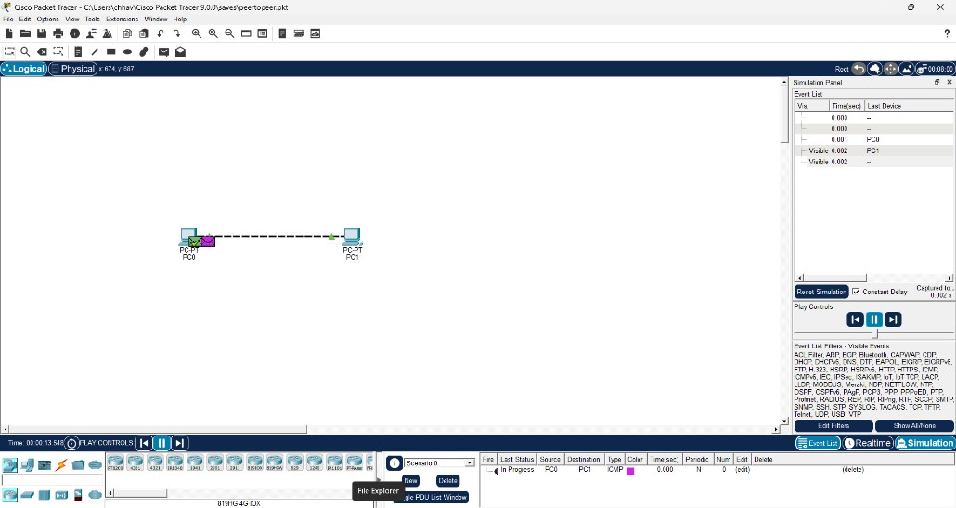

Networking Device | Purpose
Home PC | Provides components from a LAN peer-to-peer network.
Crossover cable wire | Used to connect to similar components to establish a network.

EXPERIMENT 2

VIZUALIZATING THE VARIOUS NETWORK TOPOLOGIES
- Mesh Topology
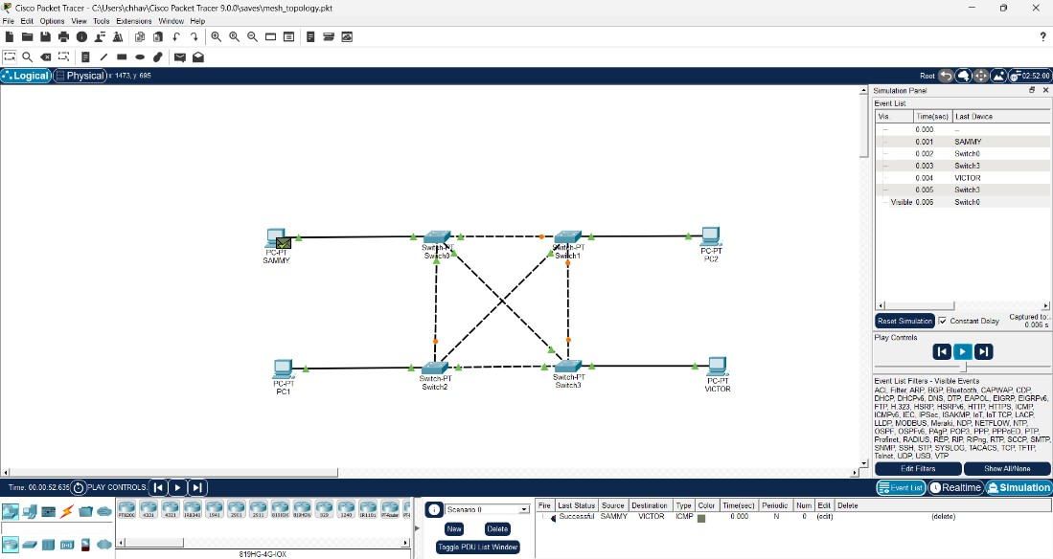

Networking Device | Purpose
Home PC | Provides components from a LAN peer-to-peer network.
Crossover cable wire | Used to connect two similar computing devices to establish a network.
Straight cable wire | Used to connect two distinct computing devices to establish a network.
Switch | Operates over the Data-Link Layer; is used to connect devices in a LAN.

Basic Ideology: The network setup where devices (nodes) are interconnected, often directly to every other node (full mesh) or to several key nodes (partial mesh).
- Bus Topology

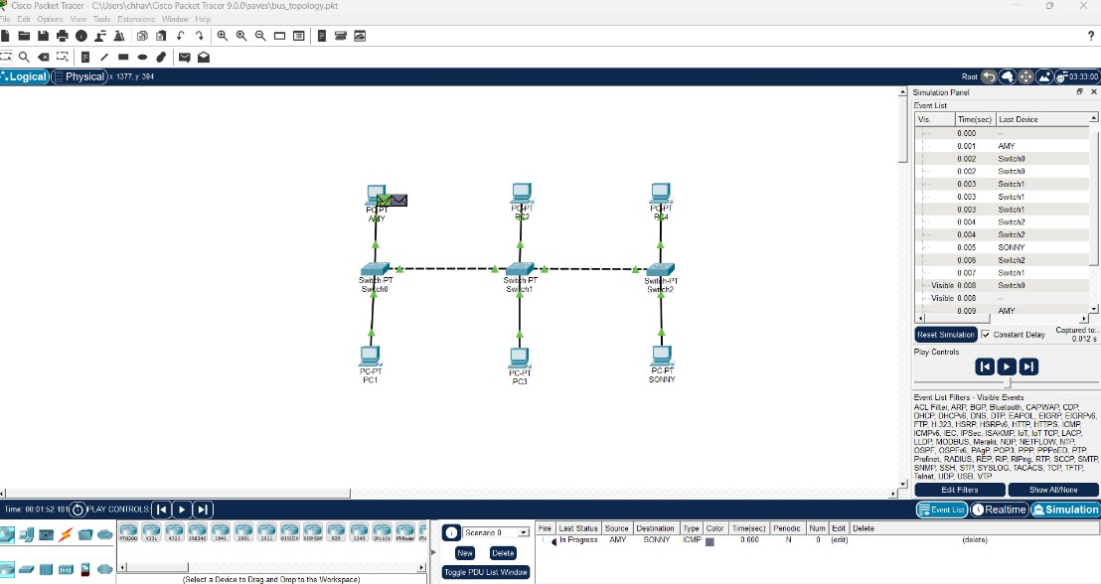

Networking Device | Purpose
Home PC | Provides components from a LAN peer-to-peer network.
Crossover cable wire | Used to connect two similar computing devices to establish a network.
Straight cable wire | Used to connect two distinct computing devices to establish a network.
Switch | Operates over the Data-Link Layer; is used to connect devices in a LAN.

Basic Ideology: The network setup where all nodes (computers/devices) connect to a single, central coaxial or RJ-45 cable called the backbone.
- Ring Topology
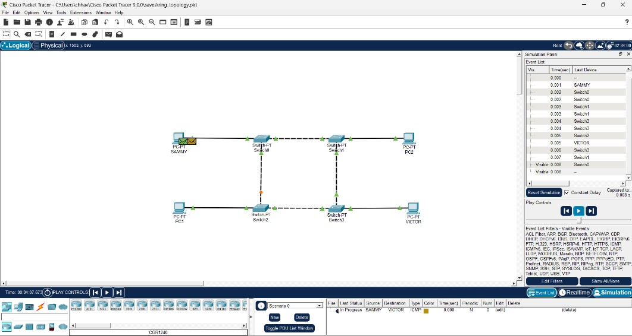

Networking Device | Purpose
Home PC | Provides components from a LAN peer-to-peer network.
Crossover cable wire | Used to connect two similar computing devices to establish a network.
Straight cable wire | Used to connect two distinct computing devices to establish a network.
Switch | Operates over the Data-Link Layer; is used to connect devices in a LAN.

Basic Ideology: The network setup where each device (node) connects to exactly two neighbours, forming a closed, circular loop.
- Star Topology
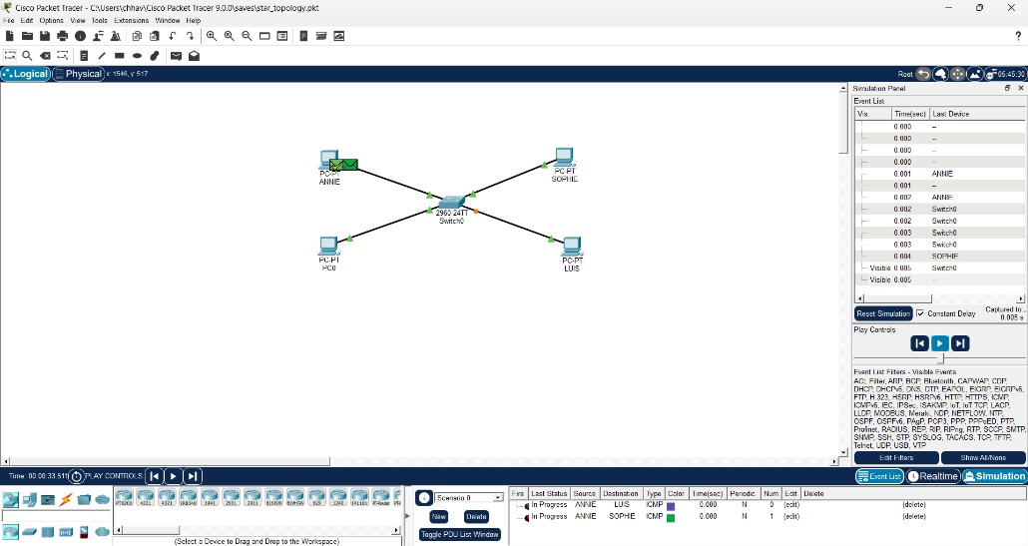
Networking Device | Purpose
Home PC | Provides components from a LAN peer-to-peer network.
Straight cable wire | Used to connect two distinct computing devices to establish a network.
Switch | Operates over the Data-Link Layer; is used to connect devices in a LAN.

Basic Ideology: The network setup where every device (node) connects individually to a central hub or switch, to form a LAN. A router is instead used to connect the one network to the other.
- Tree Topology
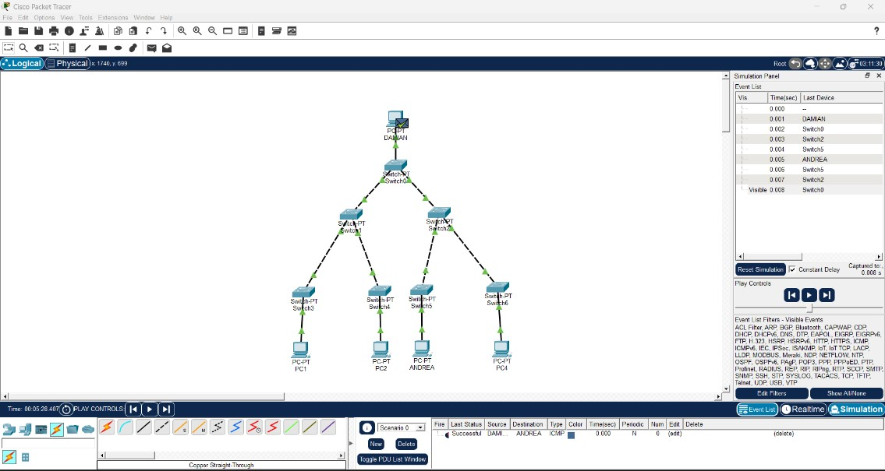

Networking Device | Purpose
Home PC | Provides components from a LAN peer-to-peer network.
Crossover cable wire | Used to connect two similar computing devices to establish a network.
Straight cable wire | Used to connect two distinct computing devices to establish a network.
Switch | Operates over the Data-Link Layer; is used to connect devices in a LAN.

Basic Ideology: It is a hierarchical network structure (also known as a star-bus hybrid) where nodes are arranged like branches on a tree, extending from a root node.

CONSTRUCTING AND UNDERSTANDING THE PURPOSE OF A LAN
- LAN using a hub.

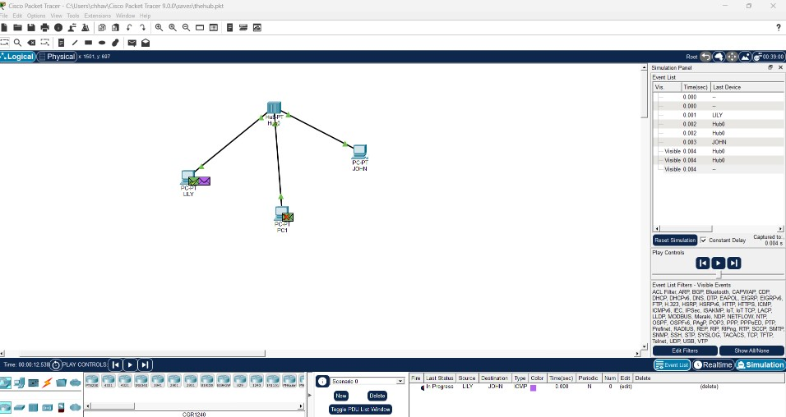

Networking Device | Purpose
Home PC | Provides components from a LAN peer-to-peer network.
Straight cable wire | Used to connect two distinct computing devices to establish a network.
Hub | Operates over the Data-Link Layer; it broadcasts messages in a LAN.

- LAN using a Switch.

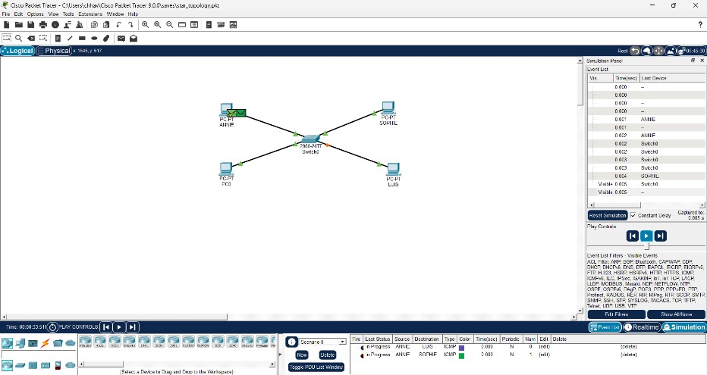

Networking Device | Purpose
Home PC | Provides components from a LAN peer-to-peer network.
Straight cable wire | Used to connect two distinct computing devices to establish a network.
Switch | Operates over the Data-Link Layer; is used to connect devices in a LAN.

IMPLEMENTATION OF A CAMPUS AREA NETWORK

(CAN): DESIGN AND IP SETTINGS

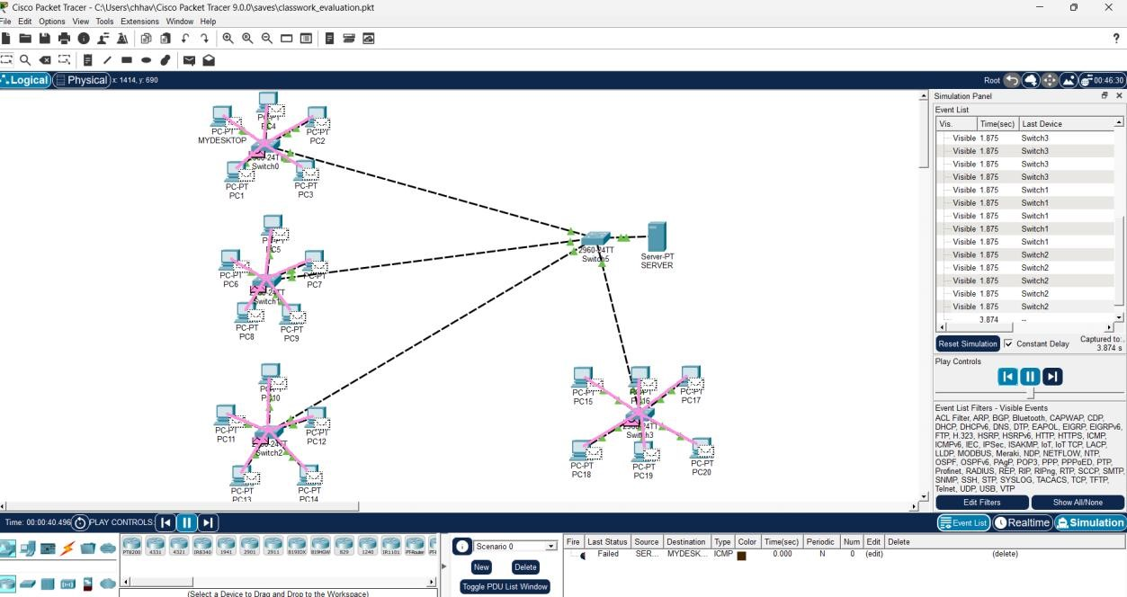

Networking Device | Purpose
Server | Used as the centralized unit in the network, that stores central database.
Home PC | Provides components from a LAN peer-to-peer network.
Crossover cable wire | Used to connect two similar computing devices to establish a network.
Switch | Operates over the Data-Link Layer; is used to connect devices in a LAN.

Basic Ideology:
The system consisted of a centralized server connected to the main switch, which acted as the core of the network. The server was used for centralized data storage, file sharing, user authentication, and management of institutional resources. Three separate floors of the campus were connected to the network, with each floor containing one laboratory of 5 PCs each. In addition, a faculty room containing 6 PCs was also connected through the same switch, enabling communication between academic staff and student labs.
A Class C private IP scheme using 192.168.20.0/24 was used for addressing. The server was assigned
192.168.20.1, and the switch management IP was 192.168.20.2. First Floor Lab PCs were assigned
192.168.20.10 to 192.168.20.14. Second Floor Lab PCs used 192.168.20.20 to 192.168.20.24. Third Floor Lab PCs were assigned 192.168.20.30 to 192.168.20.34. Faculty room PCs used 192.168.20.40 to 192.168.20.45. The subnet mask used throughout the network was 255.255.255.0.
In conclusion, the CAN design provided reliable internal communication, centralized administration, and efficient connectivity across different floors of the campus.

IMPLEMENTATING OVER THE IP LAYER
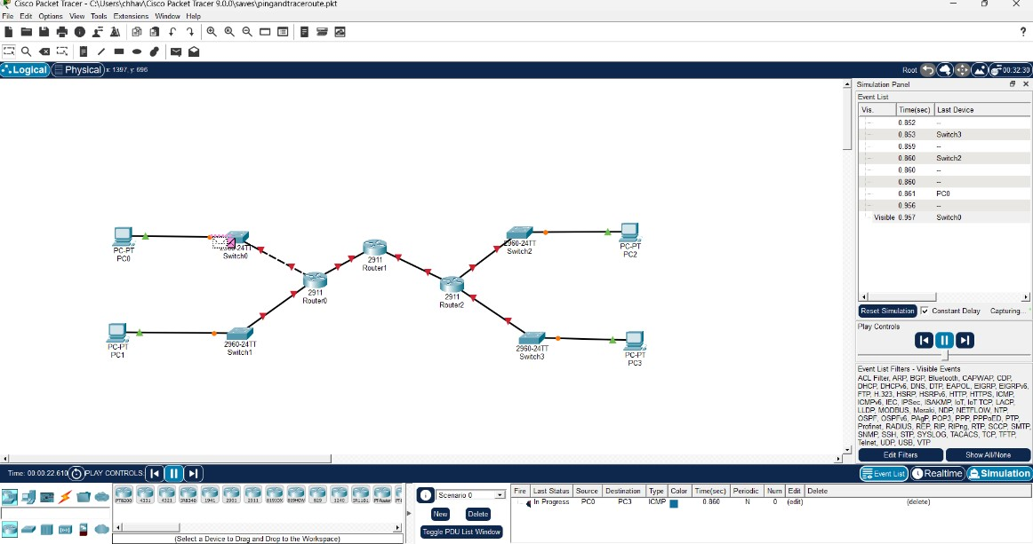
Networking Device | Purpose
Router | Operates between Layer 2 and Layer 3; and is used to connect two LANS.
Home PC | Provides components from a LAN peer-to-peer network.
Crossover cable wire | Used to connect two similar computing devices to establish a network.
Straight cable wire | Used to connect two distinct computing devices to establish a network.
Switch | Operates over the Data-Link Layer; is used to connect devices in a LAN.

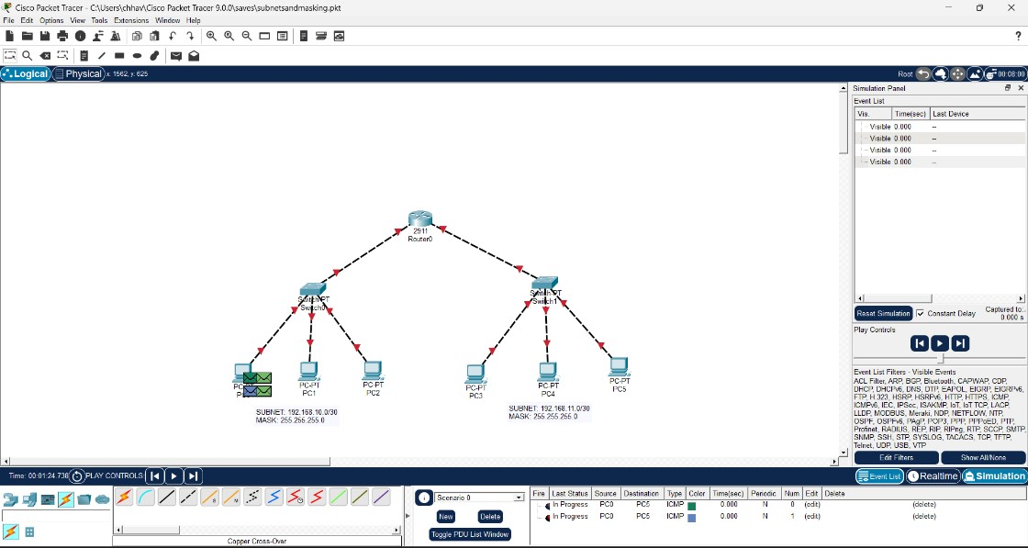

Networking Device | Purpose
Router | Operates between Layer 2 and Layer 3; and is used to connect two LANS.
Home PC | Provides components from a LAN peer-to-peer network.
Crossover cable wire | Used to connect two similar computing devices to establish a network.
Straight cable wire | Used to connect two distinct computing devices to establish a network.
Switch | Operates over the Data-Link Layer; is used to connect devices in a LAN.

WIRELESS HOME NETWORK: SETTING UP A ROUTER

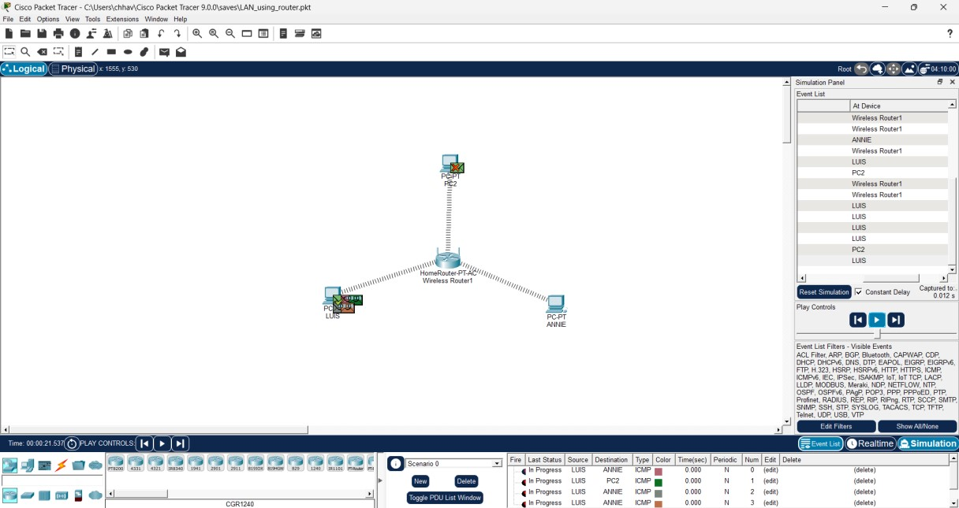

Networking Device | Purpose
Router | Operates between Layer 2 and Layer 3; and is used to connect two LANS.
Home PC | Provides components from a LAN peer-to-peer network.

Basic Ideology:
A wireless router connects multiple devices to a network using Wi-Fi and wired Ethernet connections. It routes data between local devices and the internet, assigns IP addresses through DHCP, provides network security using passwords or encryption, and enables communication among connected computers, phones, printers, and smart devices.

CAPSTONE PROJECT
SIMULATING SMART CITY IoT BACKBONE

FRAMEWORK IN CPT
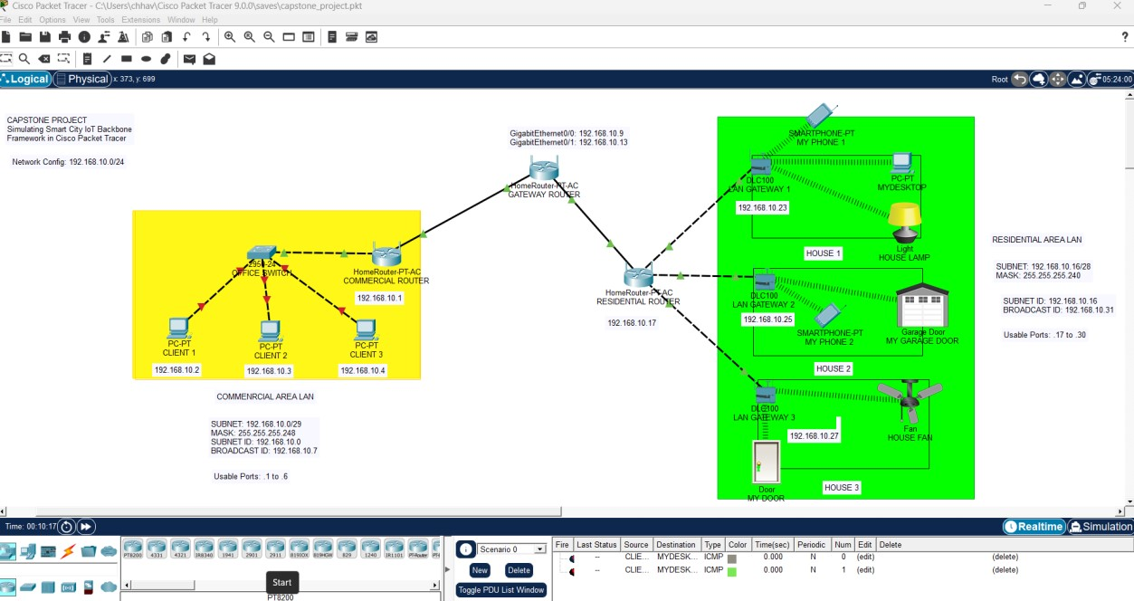

Networking Device | Purpose
Router | Operates between Layer 2 and Layer 3; and is used to connect two LANS.
Home PC | Provides components from a LAN peer-to-peer network.
Crossover cable wire | Used to connect two similar computing devices to establish a network.
Straight cable wire | Used to connect two distinct computing devices to establish a network.
Gateway | Device used to connect two separate networks; provides backbone for IoT.
Switch | Operates over the Data-Link Layer; is used to connect devices in a LAN.

Smart City Network Design Using Cisco Packet Tracer
The network was divided into two major sections: the Commercial Area and the Residential Area. In the commercial section, an office environment was created containing three personal computers connected through a switch. The switch was then connected to a commercial router, which handled traffic forwarding and routing functions. This office network represented a small business setup where multiple systems communicate through a local area network.
The residential section was connected through a core router and a residential router. Three separate houses were designed under the residential zone. Each house contained an independent home gateway to represent

smart home infrastructure. The gateways allowed wireless connection of devices such as smartphones and smart lamps, showing how IoT technology can be integrated into everyday homes.
To ensure efficient utilization of addresses, subnetting was used with the private Class C IP range 192.168.10.0/24. The commercial office network was assigned the subnet 192.168.10.0/29, supporting hosts such as PCs, switch management, and router interface addresses. Router-to-router communication links were assigned smaller /30 subnets, such as 192.168.10.8/30 and 192.168.10.12/30, which are ideal for point-to-point connections because they provide two usable host addresses only.
For the residential smart gateway section, the subnet 192.168.10.16/28 was allocated. This subnet provided a total of 16 addresses, with usable host IPs ranging from 192.168.10.17 to 192.168.10.30, which were used for the broadcasting router, three local gateways, and connected smart devices. The subnet mask used for this block was 255.255.255.240, and the broadcast address was 192.168.10.31.
The project highlights the practical use of routers, switches, gateways, wireless connectivity, and IP addressing in a real-world inspired scenario. It also demonstrates how network segmentation improves management, security, and scalability. Commercial traffic remains organized separately from residential smart home traffic, while routers allow communication where required.

